AMRITA VISHWA VIDYAPEETHAM – CHENNAI CAMPUS
DEPARTMENT OF COMPUTER SCIENCE AND ENGINEERING
23CSE302 – COMPUTER NETWORKS

EXPERIMENT 2
INTRODUCTION TO SOCKET PROGRAMMING USING PYTHON
Name: Chetan Kumar G |  | Max Marks (10)
Roll No.: CH.SC.U4CSE24109 | Section: CSE-B
Date of Exp:02/07/2026 | Date of Submission: 02/07/2026
OBJECTIVES:
- Students will gain skill set in Socket Programming
- Students will understand how a basic socket can be created using Python, resolve the hostname of a website to its IP address, and also establish a connection to the website's server

A. IMPLEMENTING A BASIC CLIENT-SERVER COMMUNICATION IN PYTHON

AIM
To create a basic client-server communication setup using socket programming in Python, where the server listens for incoming connections and the client connects to the server to exchange a simple message.

SYSTEM AND SOFTWARE REQUIREMENTS
Software – Python Terminal
Libraries - socket

PROCEDURE

- Server
  - Import Required Libraries:
    - Import the socket library.
  - Create a Socket:
    - Use the socket.socket() method to create a socket.
  - Bind the Socket to a Port:
    - Reserve an active free port on the computer (e.g., 12346).
    - Use the bind() method to bind the socket to the port.
  - Listen for Incoming Connections:
    - Use the listen() method to enable the server to accept connections.
Specify the maximum number of connections (e.g., 5).
  - Accept and Handle Connections:
    - Use a while loop to keep the server running.
    - Use the accept() method to accept incoming connections.
    - Send a thank-you message to the connected client.
    - Close the connection.
-

Client
  - Import Required Libraries:
    - Import the socket library.

  - Create a Socket:
    - Use the socket.socket() method to create a socket.
  - Connect to the Server:
    - Use the connect() method to connect to the server at the specified IP address (127.0.0.1) and port (12346).
    - Receive and Display Message:
    - Use the recv() method to receive a message from the server.
    - Print the received message.
    - Close the connection.

PYTHON CODE

- Server

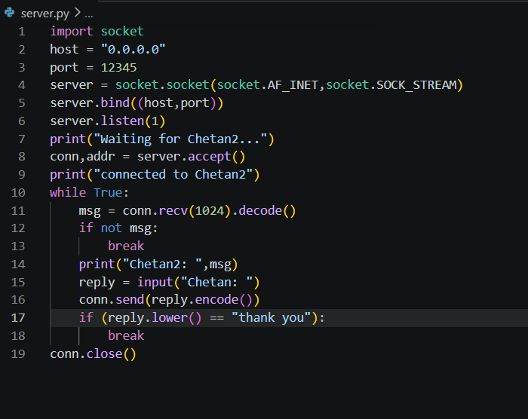

Client
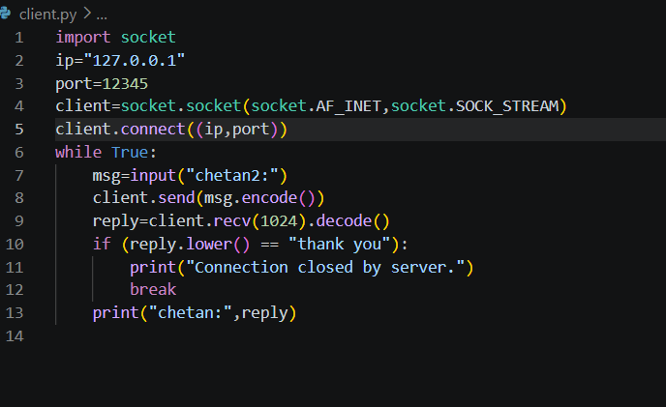

OUTPUT

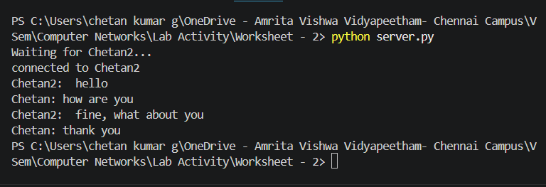

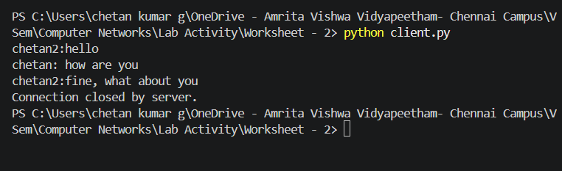

FIG 2. Client-Server Communication – short message

RESULT
The client-server communication was successfully established using Python socket programming. The server listened for incoming client connections, accepted the connection, sent the message "Thank you", and closed the connection successfully. The client connected to the server, received and displayed the message, and terminated the connection successfully.

INFERENCE

The experiment demonstrated that socket programming enables communication between a client and a server over a network. The server successfully listened for incoming connections, accepted a client request, sent a message, and closed the connection. The client connected to the server, received the message, and displayed it successfully. This verifies the basic working of TCP socket-based client-server communication in Python.

Lab Scenario: Basic Socket Programming and Client-Server Communication in Python
Scenario Title: "Employee Workstation Communication System"
Background:
Your company, TechBridge Solutions, has recently moved into a new office building. The IT department wants to test basic internal communication between employee workstations using custom Python socket programs, before deploying more complex systems.
You have been assigned to build a simple network communication prototype using Python socket programming, where:
- Each workstation can act as a client.
- A central server runs on the manager’s machine and listens for messages.
- Clients should connect to the server using the hostname and IP address of the server machine.
- Once connected, they should be able to send a short message like “Hello from Workstation 3” to the server.
- The server should print and acknowledge every message received.

Part A: Basic Socket Programming and Host Connection
- Write a Python program to retrieve and print:
  - The hostname of the local machine.
  - The IP address of the local machine.
CODE:
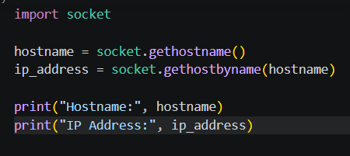
OUTPUT:
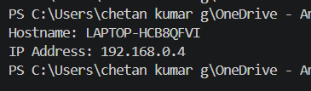
Q1: What is the hostname and IP address of your system?

- Write another Python program that:
  - Resolves the hostname of a given remote server (e.g., "www.google.com") to its IP address.
Q2: What is the IP address of www.google.com resolved by your code?
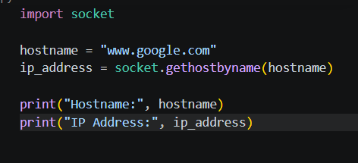
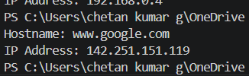

Part B: Implementing Basic Client-Server Communication
- Server-Side Requirements:
  - Create a Python socket server that:
    - Listens on a port (e.g., 12345)
    - Accepts connections from clients
    - Receives a message and prints it
    - Sends back an acknowledgment: "Message received"
- Client-Side Requirements:
  - Create a client that:
    - Connects to the server using its IP and port
    - Sends a message (e.g., "Hello from Workstation X")
    - Receives the acknowledgment and prints it
Q3: Did the server receive the message from the client? Paste the output from both client and server terminals.
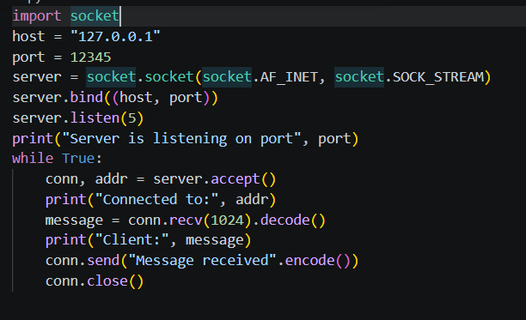
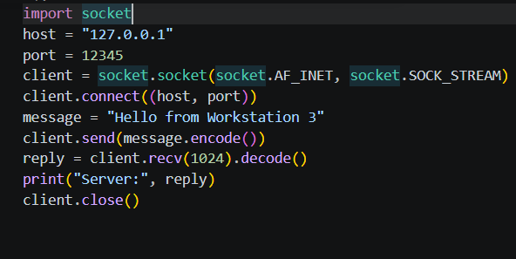

Extension Task (Optional Challenge):
Modify the server to handle multiple clients using threading so that it can process messages from several workstations at once.
Q4: How did you implement multithreading? Did the server respond to all clients without blocking?

Multithreading was implemented using Python's threading module. Each time a client connected, the server created a separate thread to handle communication with that client. This allowed multiple clients to communicate with the server simultaneously without waiting for previous clients to disconnect.

Yes. The server responded to all connected clients independently without blocking other incoming connections, demonstrating concurrent client handling.

